**A) Define the followings: [8]**

1. Define AI agent.

An agent perceives its environment through sensors and acts upon it through actuators (or effectors, depending on whom you ask). The Agent takes its action(s), which changes the environment, and process repeats.

1. What is back propagation and why do we use it?

Algorithm for training neural networks with hidden layers. Calculate error for output layer and propagate error back layer wise and update weights.

1. How supervised and reinforcement learning are related?

Both Supervised and RL get feedback:

Supervise Learning get feedback in form of Labeled Class

RL get feedback in form Reward.

1. Define the role of activation function and give the name of popular activation function.

Activation function is non-linear function which is used activate/ trigger particular neuron. Sigmoid, tanh, RELU are mostly commonly used activation functions.

1. Differentiate between Markov decision process and reinforcement learning.

In MDP transition probability and rewards are known. In RL transitions and rewards are unknown and it is estimated through interacting with Environment

1. Given the figure below, determine the followings:
2. Whether A and B are conditionally independent given C is observable (NO)

No. If C is observed than probability A can effect the probability of B so they are not independent.

1. Whether A and B are conditionally independent given C is unobservable (YES)

Yes. They are conditional independent if C is unobserved. Probability of A does not affect probability of B.

1. What is the concept of gradient descent in neural network?

Gradient descent is used to minimize the loss function of neural network. We choose any starting point in weight space and then move to a neighboring point that is downhill, repeating until we converge on the minimum possible.

1. Explain the difference between impurity and abnormality of a Dataset?

|  |  |  |  |
| --- | --- | --- | --- |
| Applications | PEAS | Environment Type | Agent type |
| PDF] Smart prayer mat: A textile-based pressure sensor to assist elderly  with cognitive impairment in praying activity | Semantic Scholar  AI-enabled Prayer mat |  |  |  |
| A helicopter flying over a red box  Description automatically generated with low confidence Ambulance drone |  |  |  |
| Boltt unveils smart wearable ecosystem with AI-enabled mobile app at CES  2017 - Android Authority  AI-enabled smart shoes |  |  |  |
| Top 10 Data Science Applications – Data Catchup Autonomous car |  |  |  |

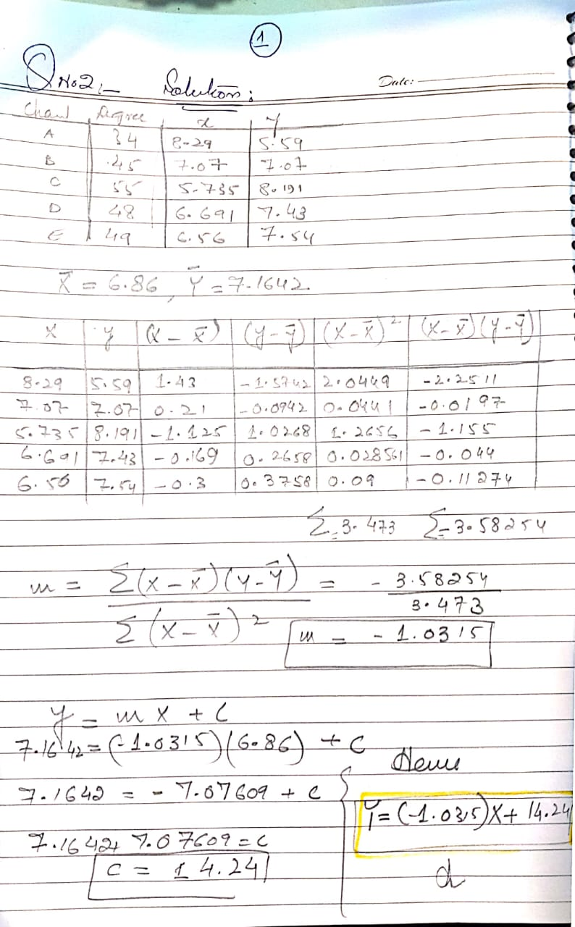

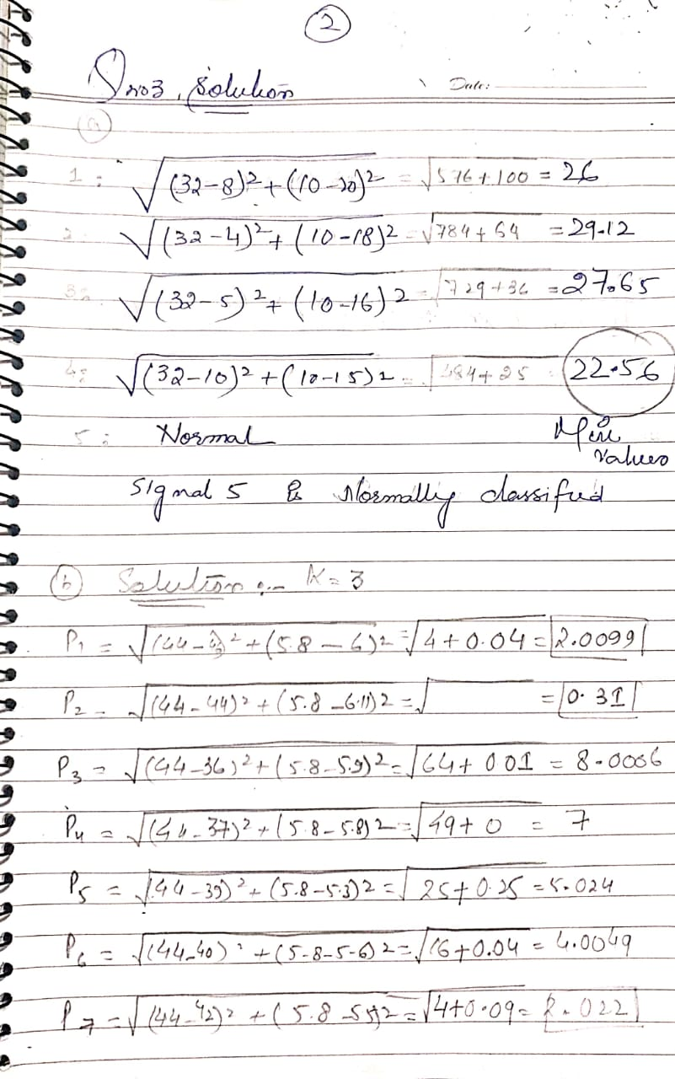

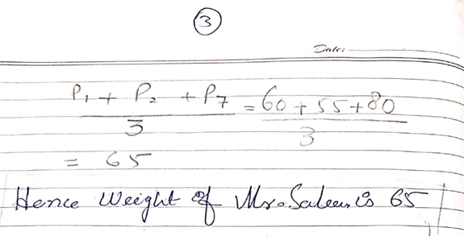

Q 4 a

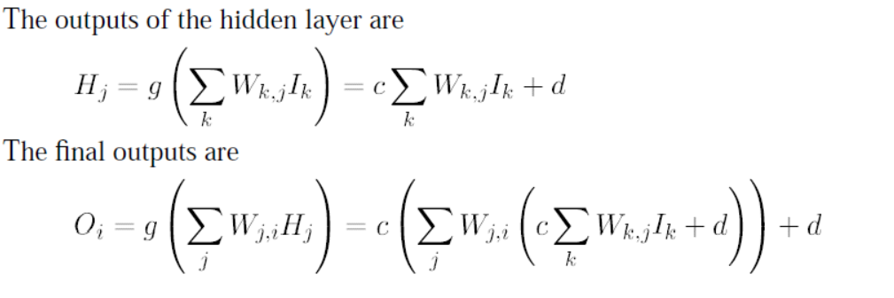

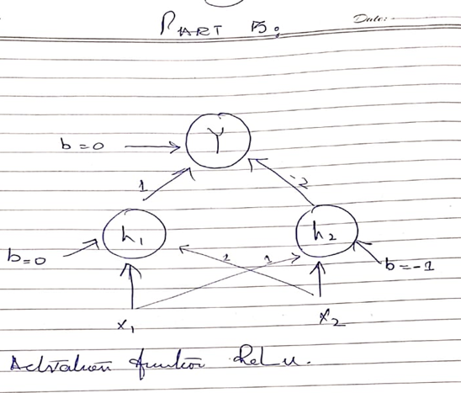

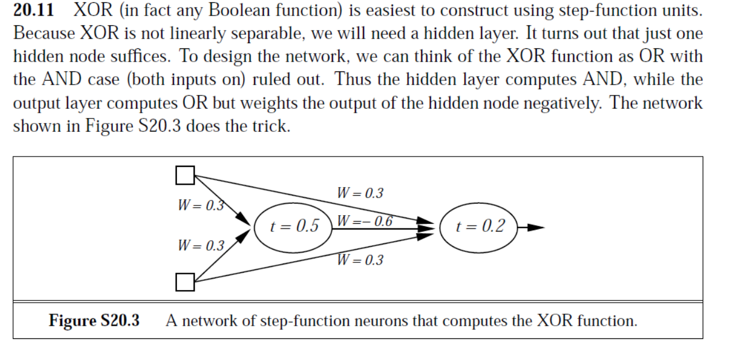

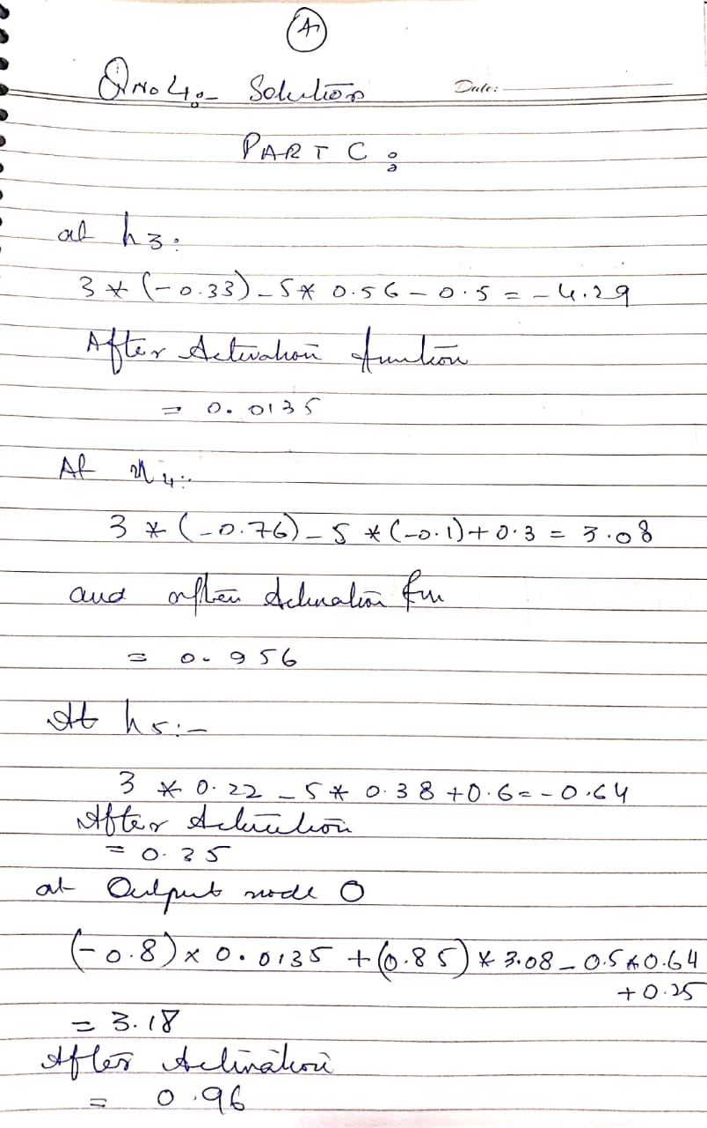

Q 5

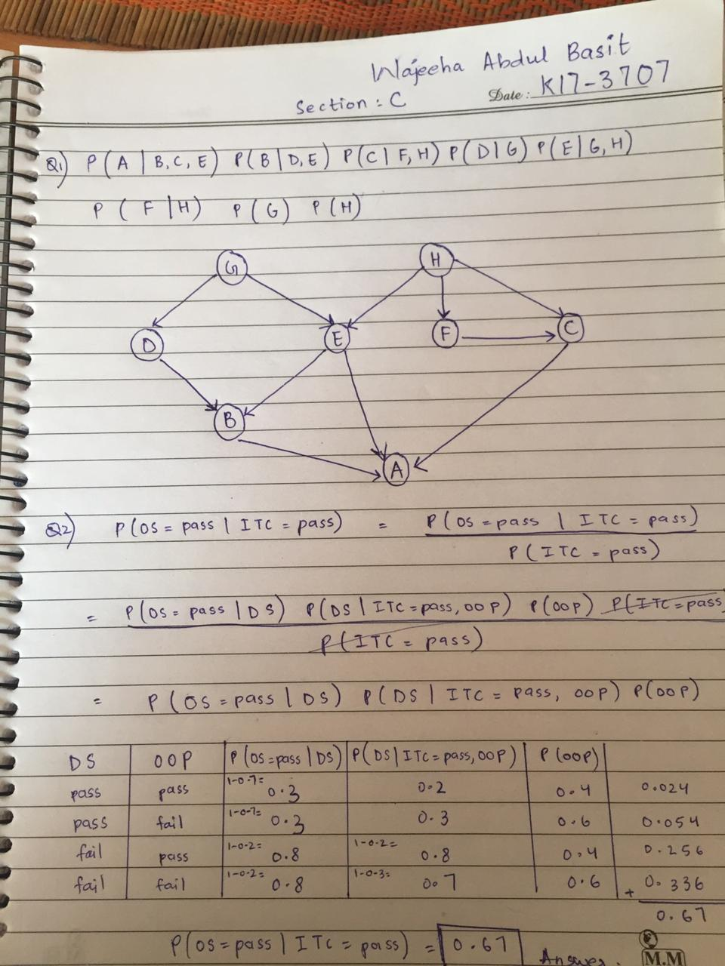

Q 6:

|  |  |  |  |
| --- | --- | --- | --- |
| **Applications** | **Supervised LEARNING Methods**  **With one line justification** | **Unsupervised Learning Methods**  **With one line justification** | **Reinforcement Learning**  **With one line justification** |
| Hate Speech Detection | Yes |  |  |
| Self-driving car |  |  | Yes |
| Rescues robots |  |  | Yes |
| Stock Market prediction | yes |  |  |
| Bank transaction fraud detection | Yes |  |  |

